- As a user, I want to add a new product or update a current product in the system.

- Steps

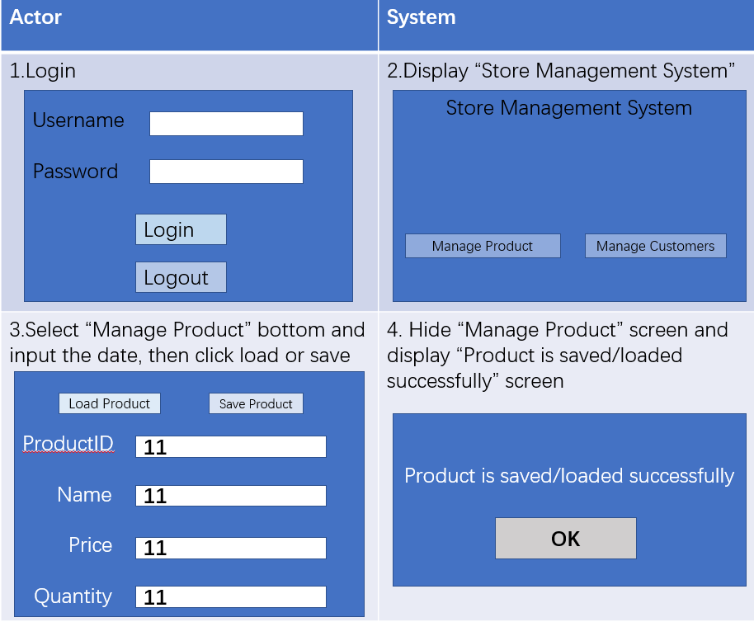

- As a user, I want to add a new customer or update a current customer in the system.

- Steps

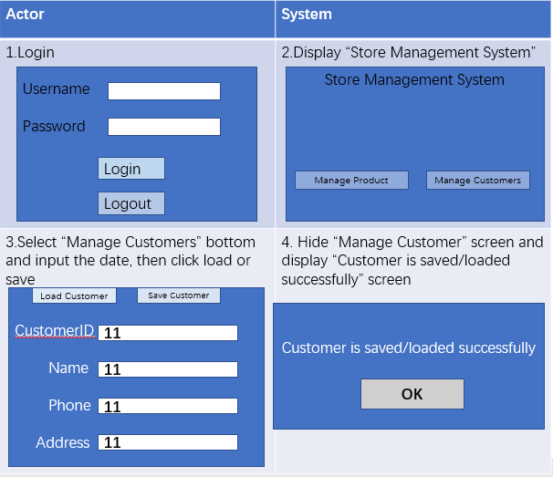

- As a user, I want to add a new purchase or update a current purchase in the system.

- Steps

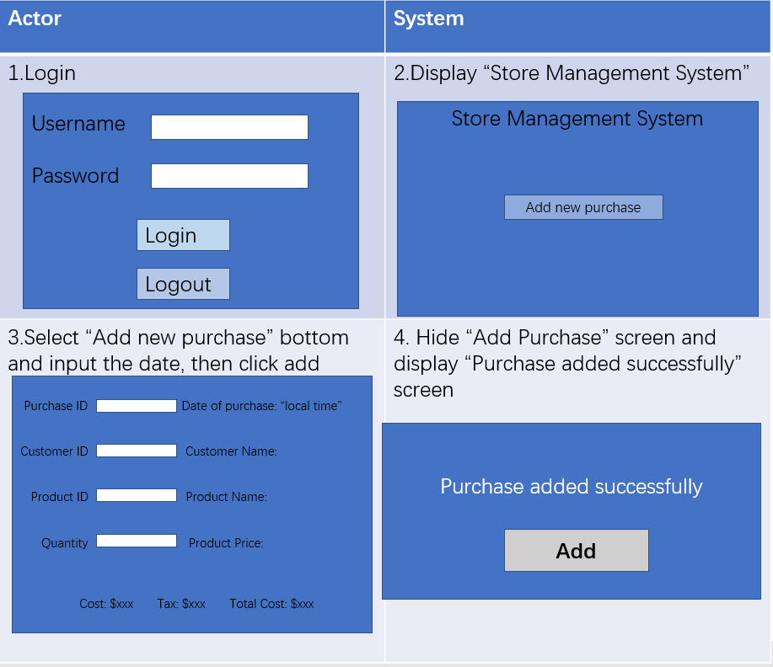

the protocol for two sides: client and server.

Client:

Function client communicate and linked with the server first by establishing a connection with a server at runtime, then the information will be updated into the serve through the users’ requests which contain information about the data being requested / to be used by the server. These requests are then converted to a JSON string before being sent over. Before a server is at runtime, the client should be linked to it for the connection.

Serve:

Function serve communicate with multiple clients at once through the “serve loop”. It will creates a new thread to deal with each individual connection. Information is sent from the server to the clients using Responses. These responses will always be sent in response to a server request coming from the client. These responses are converted to a JSON string before being sent over.